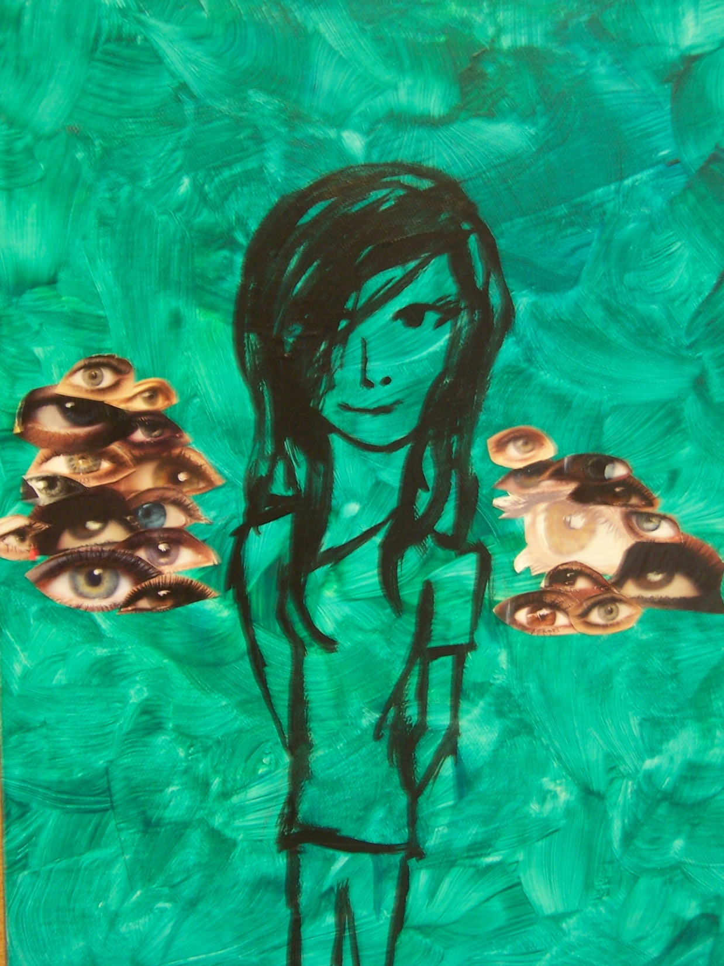
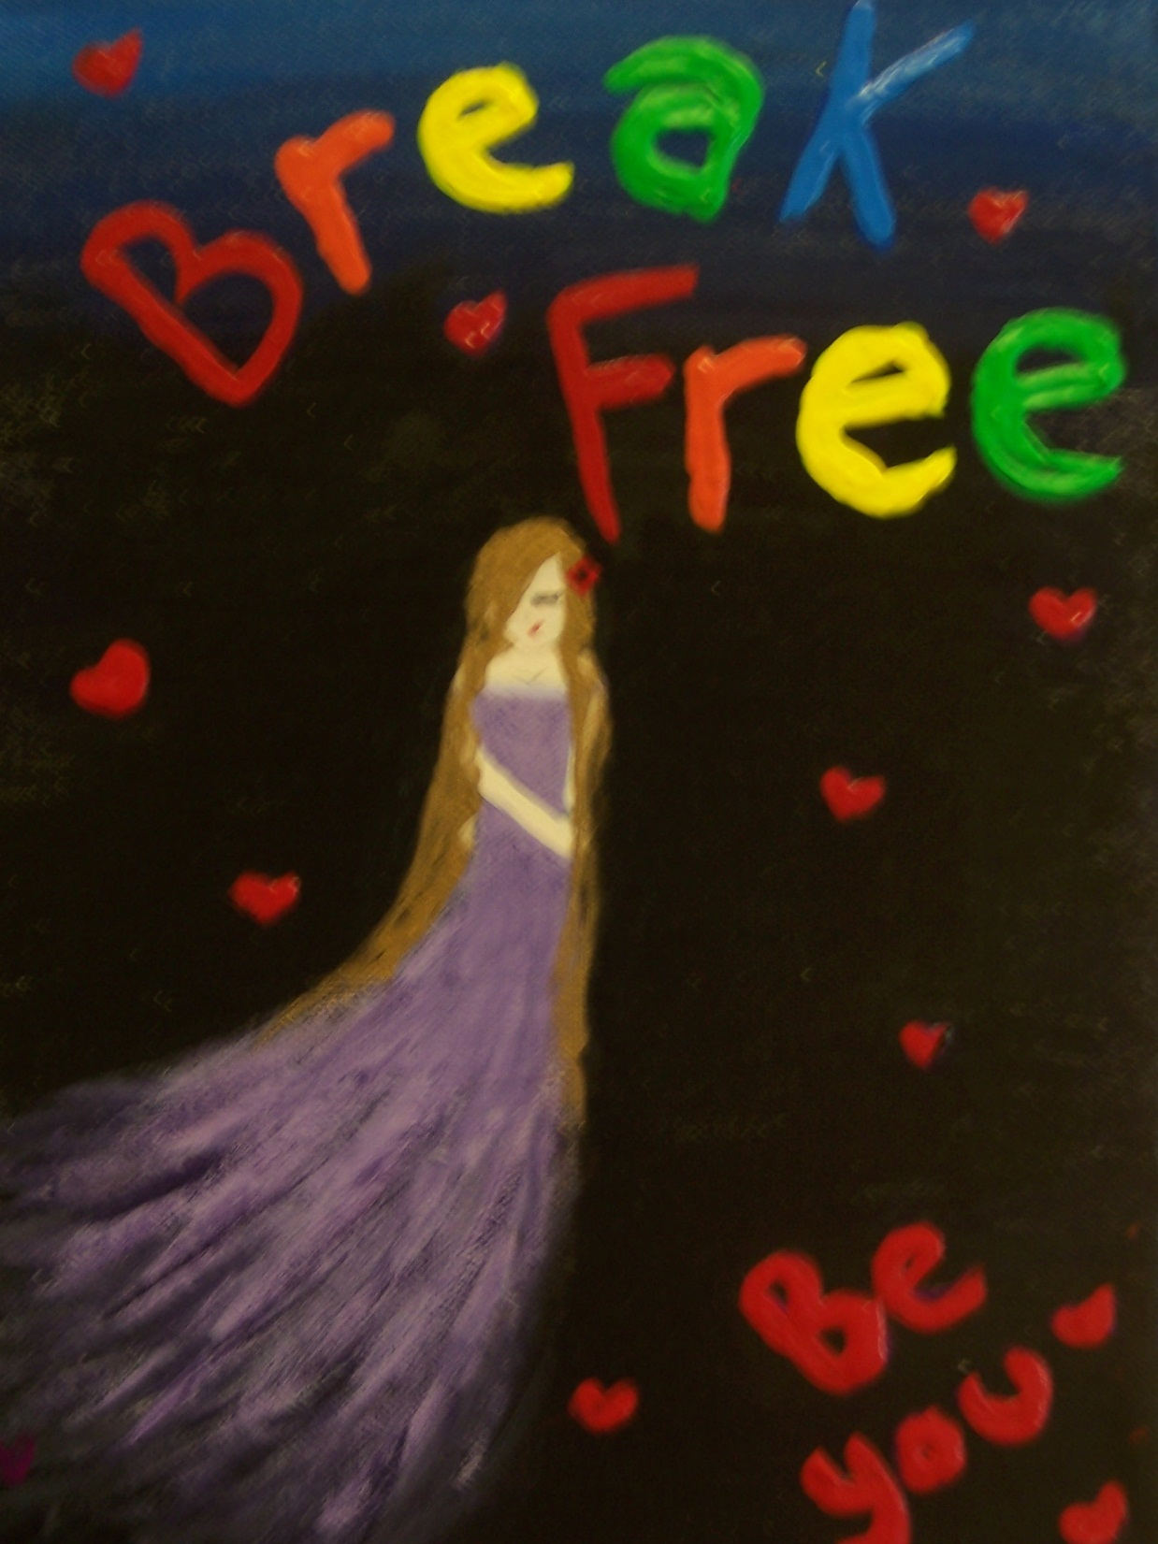
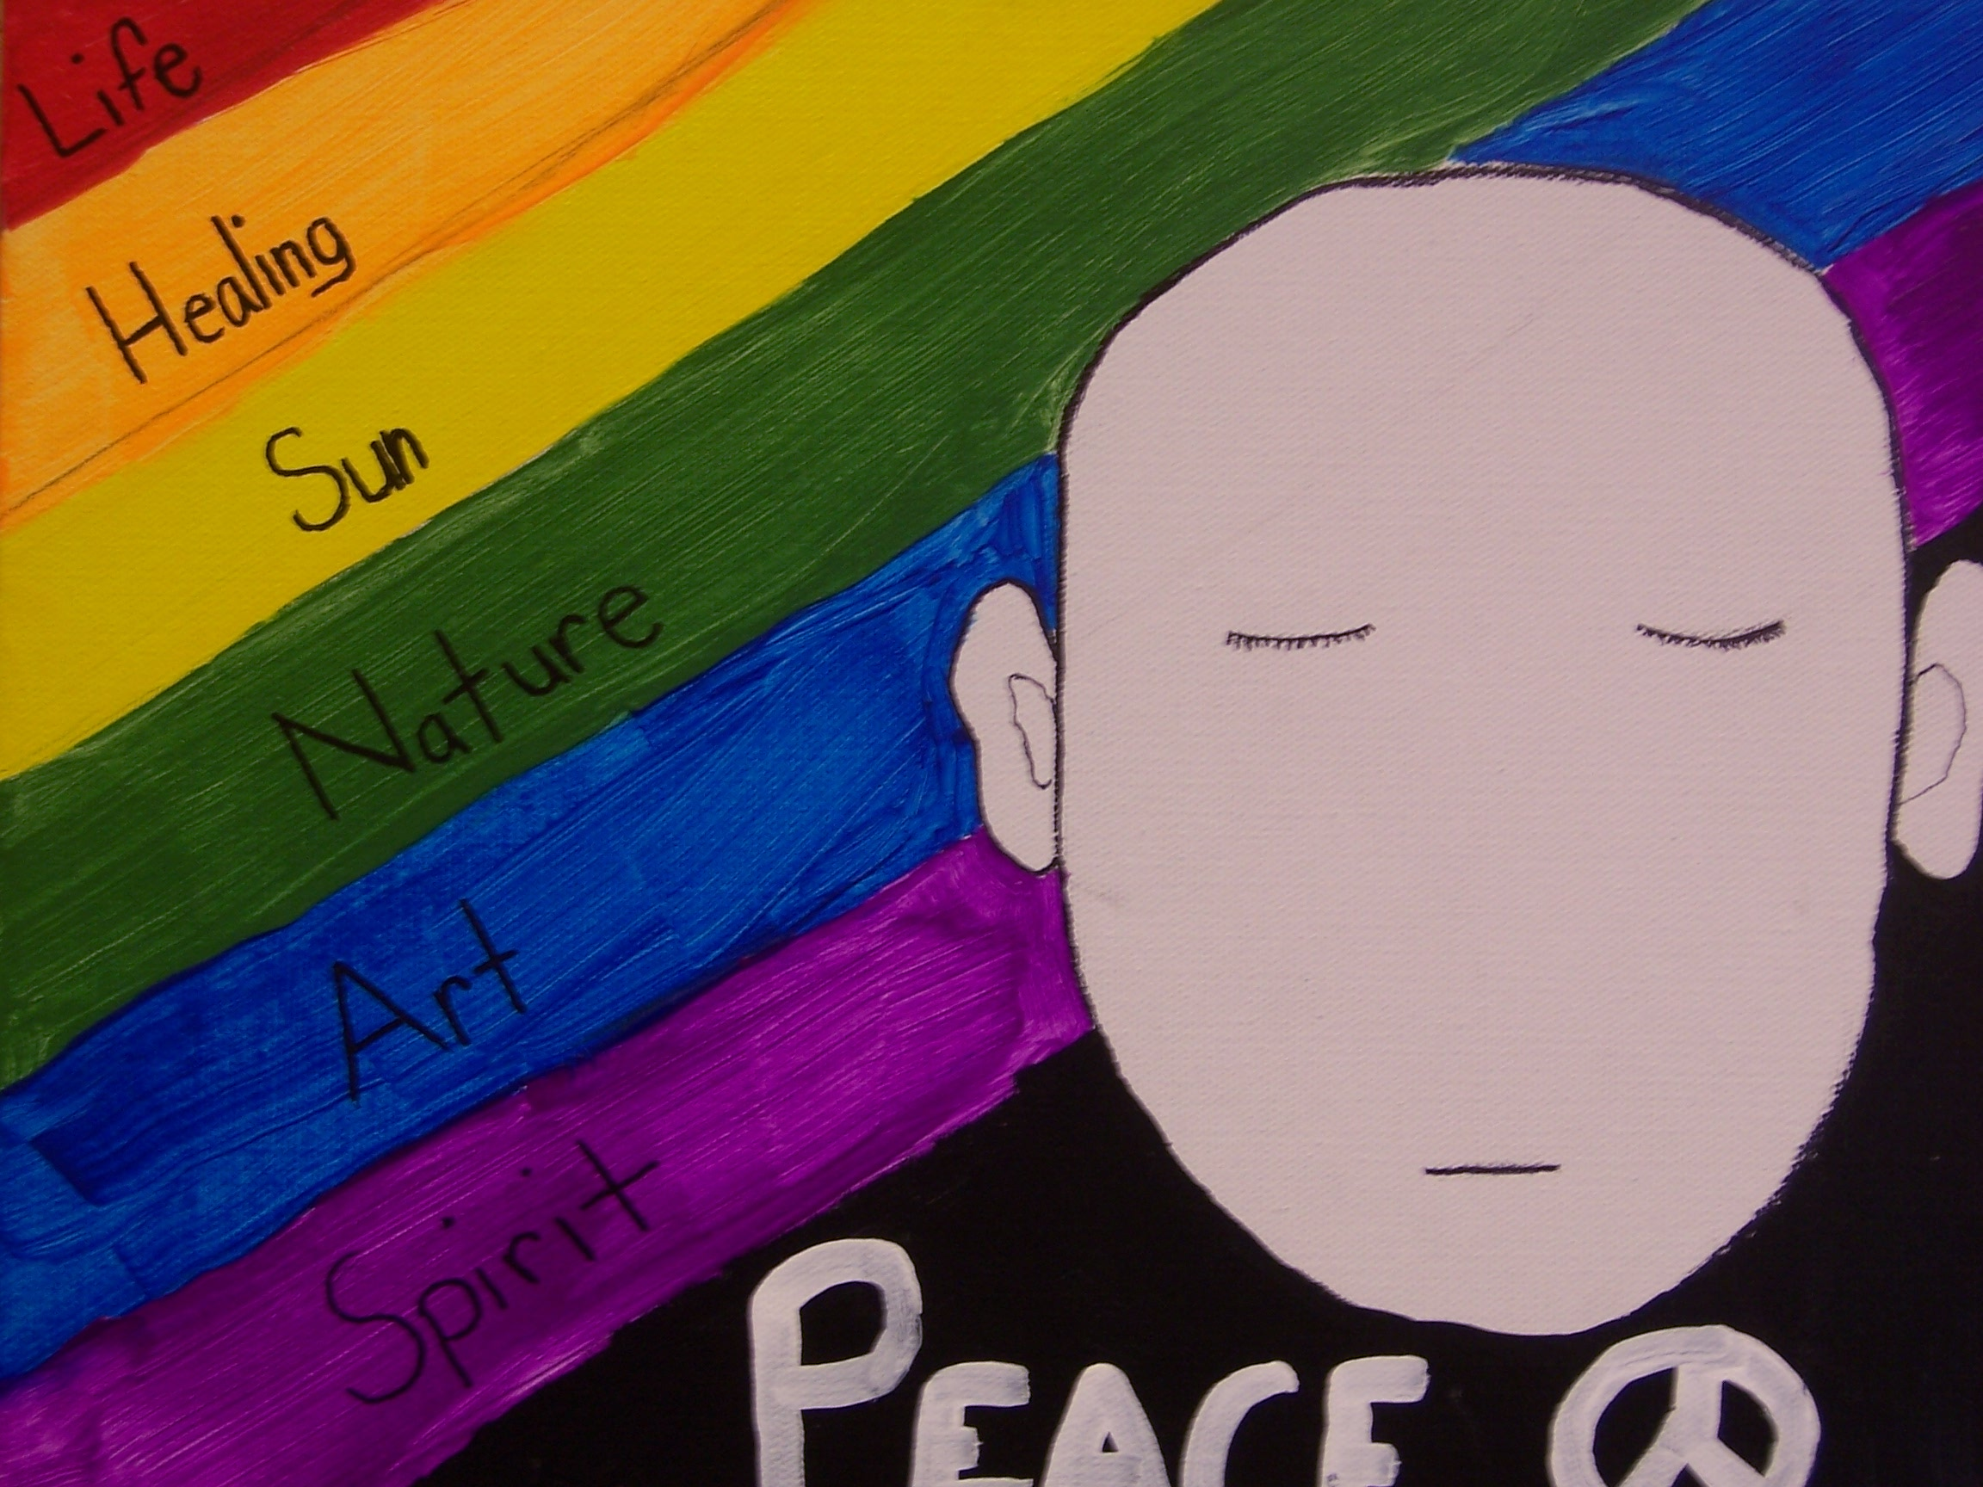
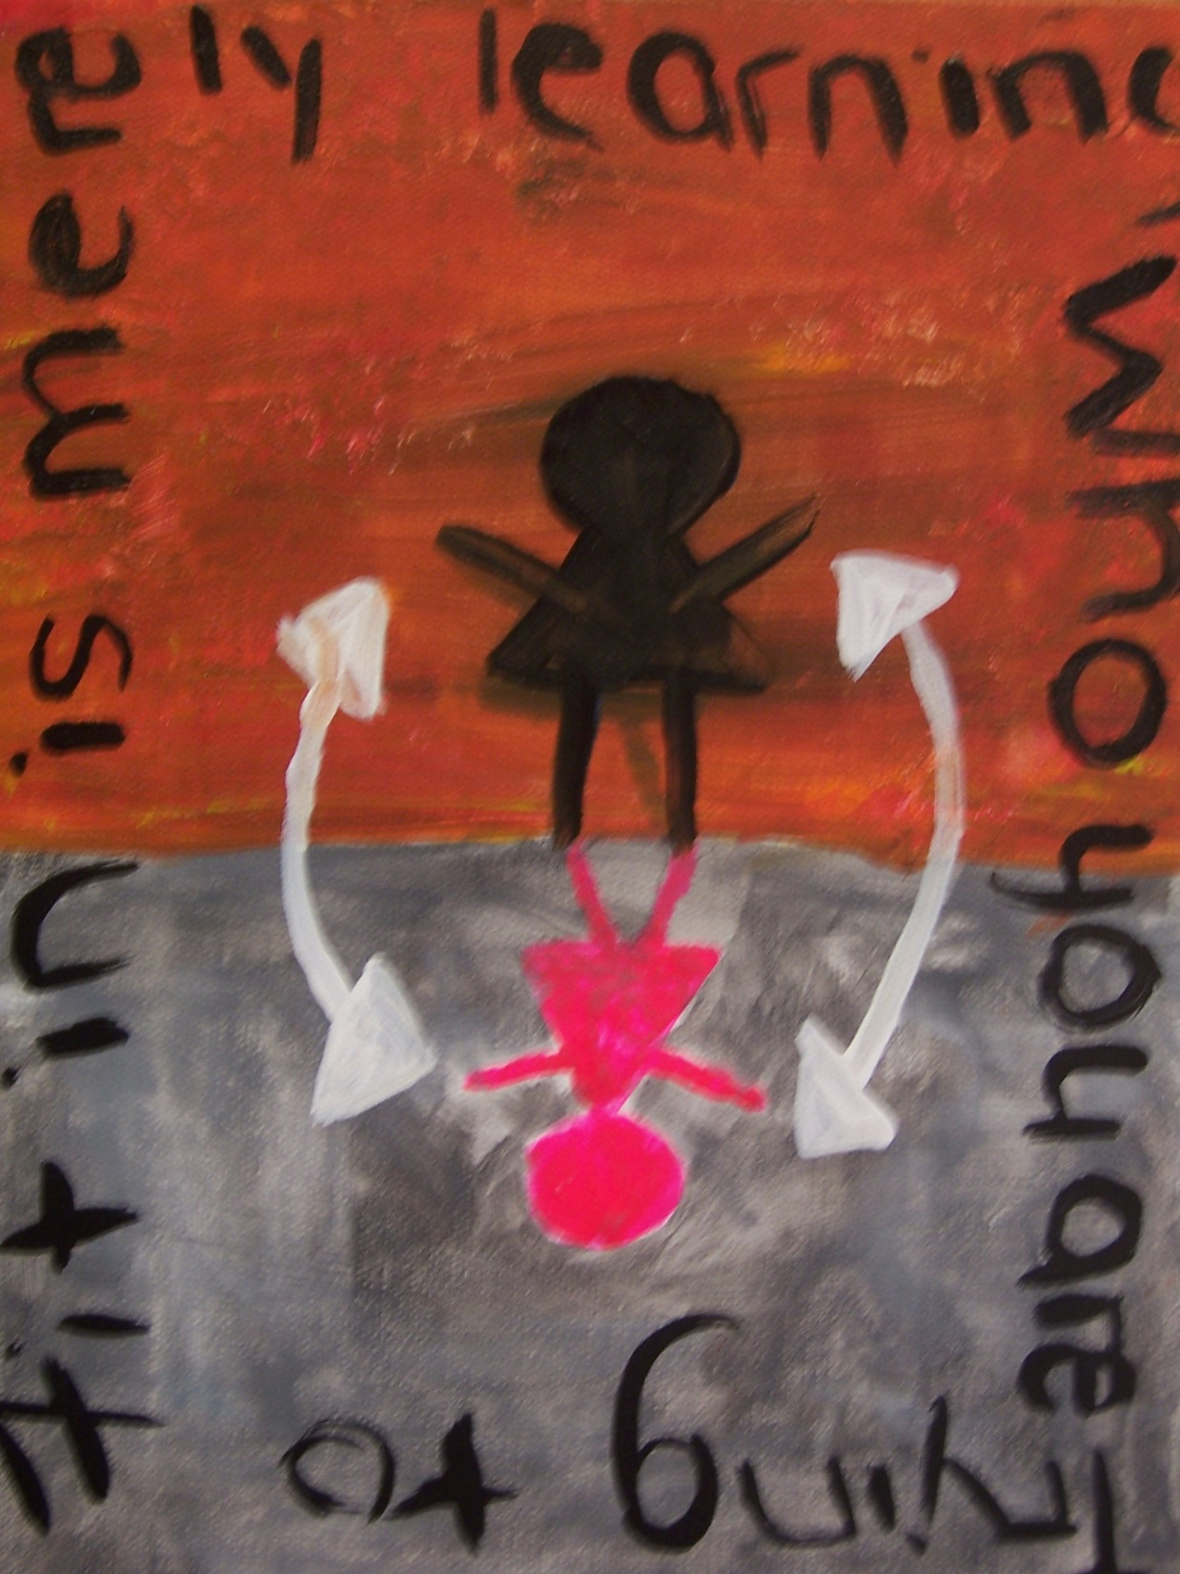

In preparation for New York State’s implementation of the Dignity for All Students Act,
The Queering Education Research Institute (QuERI) in the Syracuse University School of Education invites all K-12 Educators to participate in

Queer Students CNY: A Day of Art, Education, and Action
12:30-6:30
Friday, April 1, 2011

- Lesbian, Gay, Bisexual, Transgender and Queer students are three times more likely than their heterosexual peers to drop out of school.
- 98% of ALL high school students report hearing LGBTQ verbal harassment on a daily basis.
- New York State’s Dignity for All Students Act (DASA) will take effect in 2012 and will require schools to provide supportive learning environments for LGBTQ and gender non-conforming students.
- Few teacher preparation programs address the issues faced by LGBTQ students and the children of LGBTQ families and many educators do not have the information and tools they need to move toward supporting LGBTQ students.
- This half-day workshop offers opportunities to learn about the LGBTQ in-schools experience and envision DASA compliance in your school.

The Reduction of Stigma in Schools (RSIS), a program of QuERI, has been offering professional development in support of LGBTQ students in area schools since 2006. A number of RSIS workshops will be offered throughout the afternoon including: Supporting the Transgender Elementary School Student; Bullying, Gender Policing and Middle School; The LGBTQ High School Experience; Looking Toward DASA Compliance. Artwork from over 60 area youth exploring their experiences as LGBTQ students in Central New York will provide the backdrop for the workshop presentations. An original theatre piece on being LGBTQ in CNY schools will also be preformed by students. The day will conclude with a panel of LGBTQ students discussing their experiences in schools and sharing their vision for more supportive school environments.

Continuing Education Units (CEUs) are available. Information on parking at reduced rates ($6) available at time of registration.
Registration for Educator Training Workshop: Queer Students CNY: A Day of Art, Education, and Action. April 1, 2011. 12:30-6:30. Syracuse University XL Projects Gallery, 307 South Clinton Street, Syracuse, NY. $6.00 parking fee payable at event.

NAME__________________________________________________________________________
SCHOOL DISTRICT_____________________________ SCHOOL___________________
E-MAIL___________________ PHONE____________________________
DO YOU WANT PARKING? Yes or No
DO YOU WANT CEUs? Yes or No
Please mail or e-mail registrations BY MARCH 25 to: QuERI, 350 Huntington Hall Syracuse, NY 13244.
Questions? 315 443-3343; www.queeringeducation.org; or e-mail rsis@syr.edu

